CSC-654 Algorithms Analysis / Design

Homework #5

By Mostafa Abdelmegeed

# Problem 15.1-3 from book



# Problem 15.1-5 from book



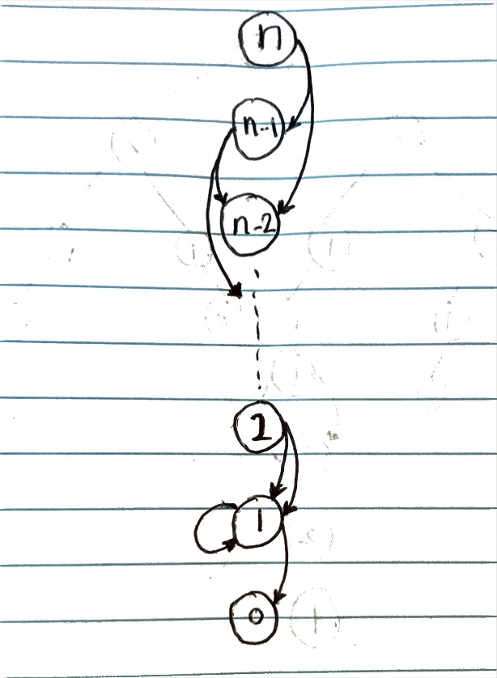

Assuming by edges the question means the number of times the recursion calls for the particular node is called, there will be **n+1** edges in the graph, and the number of nodes will be **n**

# Problem 15.3-6 from book

## Part I

Assuming commission 0, considering an optimal sequence S from currency 1 to n.

let P be the first part of the sequence (1 to k) and let Q be the second part of the sequence (k to n), where considering S to be a combination of {PQ}

Now considering another path for the first sequence, say P' to be optimal and P to not be.

Now there is a change in sequence, and the new sequence is S', where S' is a combo of {P'Q}

with this, we can deduce that S' is better than S, which is a contradiction of our original assumption.

Hence proving that an optimal substructure exists.

## Part II

Let’s let the conversion from i to j be 0.9. Let’s let the conversion from j to k be 0.9. Finally, let’s let

the conversion from i to k be 0.89.

Let’s also let the cost of making 1 trade .7 unit of currency i while making 2 trades costs 0.3 units of

currency i, any number of trades more than that costs 100 currency units per trade.

Let’s say I have 1 in currency i and I want currency k.

If we just look at the way the commissions are structured, by making 2 trades instead of 1 trade, we

save .7 units of currency i. The best way to go from currency i to currency k would be go from i to j

then k. Which would result in .81 - .3 = .51. Note this is better than going from i to k directly, which

would be .89 − .7 = .19.

The best path from i to j would be not just i to j directly, however, since making that second trade

saves you a fortune. That path would be i to k, then k to j, which would be 0.801 − .3 = .501 vs going

directly would be .9 − .7 = .2.

Since the optimal path for a sub-problem if that problem was the whole problem is not a solution for

when it is part of the overall problem, this problem no longer has optimal substructure property if ck

can be arbitrary values.